47th National Chemistry Olympiad

Utrecht University

PRACTICAL EXAM

Answer sheets

Tuesday 9 June 2026

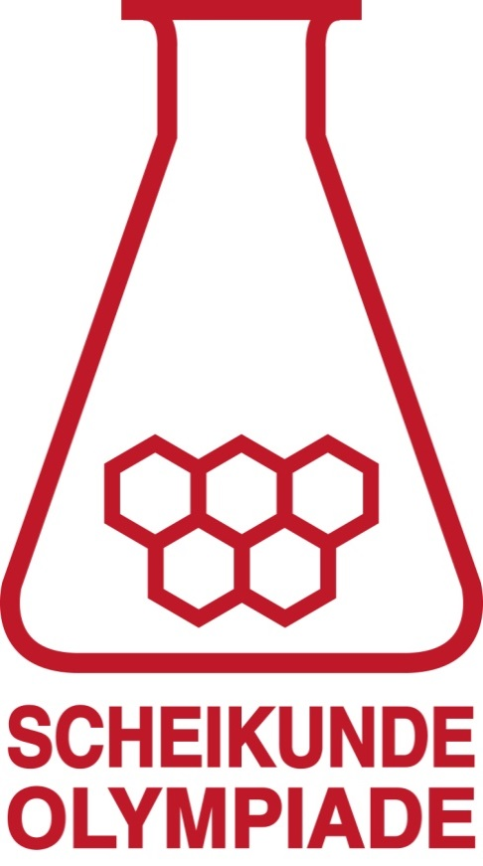
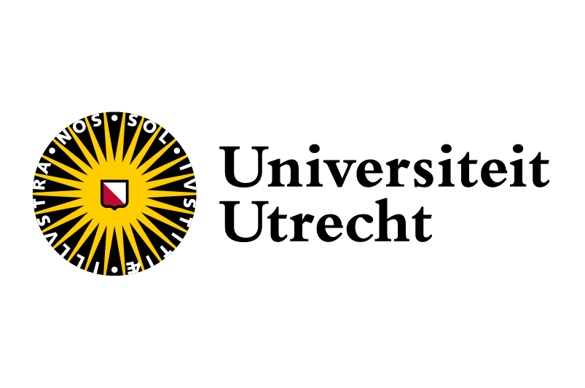
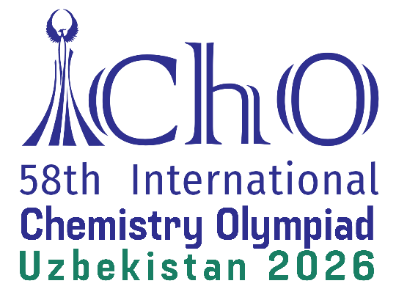

Answer sheets for the practical exam
Experiment 1
Question 1
Question 2
Question 3
Question 4
number of mL of alcohol ………….
number of mL of triethylamine ………….
number of mL of acid chloride ………….

Question 5
Question 6
mass of the empty round-bottom flask ………….
mass of the round-bottom flask with ester ………….

Question 7
Question 8

Answer sheets for the practical exam
  - Experiment 2
Question 9
caustic soda molarity: ………….

Question 10
first titration
mL caustic soda | pH | mL caustic soda | pH

second titration
mL caustic soda | pH | mL caustic soda | pH

Question 11
first titration


second titration

Question 12
Question 13
Question 14
calculation of the pH after adding 5.0 mL caustic soda

calculation of pH at equivalence point

